Pokhara University

Level: Bachelor | Semester – Spring | Year : 2006
Programme: BE |  | Full Marks: 100
Course: Engineering Mathematics IV |  | Time : 3hrs.

Candidates are required to give their answers in their own words as far as practicable.
The figures in the margin indicate full marks.

Attempt all the questions.

 | - Define analytic function. Show that the function  u (x, y) = 3x²y + x² – y³ – y² is a harmonic function. Find a function v(x, y) such that u + iv is an analytic function.  - Evaluate 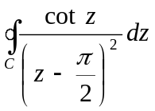, where C is the ellipse 4x² + 9y² = 36. | 8  7
 | - Define Pole and Zeroes of a function. State Cauchy’s residue theorem and evaluate 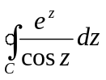where 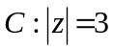.  - Define Z - transform. State and prove first shifting theorem of Z- transform. Using it evaluate 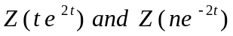.  OR  Find the inverse Z – transform of 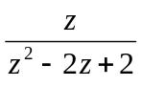. | 8  7
 | - Find the Fourier integral of the function 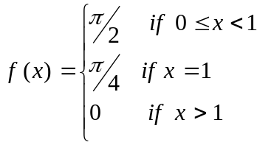  - Find the Fourier cosine transform of 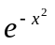  OR  Find the Fourier transform of the function 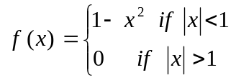 | 7  8
 | - Derive one dimensional wave equation of an elastic string which is tightly stretched to the length L and two ends are fixed.  - Find the temperature in a laterally insulated bar of length L whose ends are kept at a zero temperature, assuming that the initial temperature is 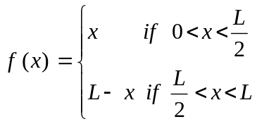 | 7  8
 | - Solve the differential equation by using Z – transform 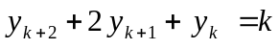 where 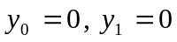  - Maximize:  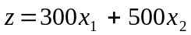subject to:  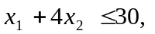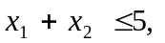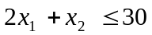 | 7  8
 | - Define Fourier sine and cosine integrals. Show that 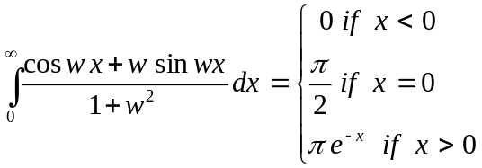  - Define convolution of the two functions. If f(x) and g(x) are piecewise continuous, bounded and absolutely integrable on the x- axis then F(f*g) = 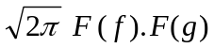  OR  Find the Fourier transform of 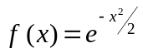 | 8  7
 | Attempt all the questions:  - Find Maclaurin expansion of the function 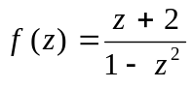  - Solve the differential equation by using separation of variables:  u_{xy} – u = 0.  - Find Z- transform of 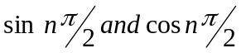  - Write equation of an ellipsoid. Sketch it with centre and axis of symmetry.  - Show that 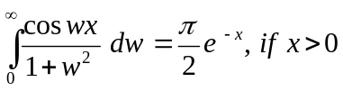. | 2×5

